**SIMATS SCHOOL OF ENGINEERING**

**SAVEETHA INSTITUTE OF MEDICAL AND TECHNICAL SCIENCES**

**CHENNAI-602105**

# NETFLIX CLONE

**A CAPSTONE PROJECT REPORT**

*Submitted in the partial fulfilment for the award of the degree of*

**BACHELOR OF ENGINEERING**

**IN**

**COMPUTER SCIENCE**

**Submitted by**

**A. MUKESH KUMAR (192211644)**

**I.DINESH REDDY (192211306)**

**Under the Supervision of**

**Ms.B.JEEVASHRI**

**JUNE 2024**

## DECLARATION

**We, A. MUKESH, I. DINESH REDDY, students of Bachelor of Engineering in Computer Science and Engineering,** Department of Computer Science and Engineering, Saveetha Institute of Medical and Technical Sciences, Saveetha University, Chennai, hereby declare that the work presented in this Capstone Project Work entitled is the outcome of our own bonafide work and is correct to the best of our knowledge and this work has been undertaken taking care of Engineering Ethics.

1. A. MUKESH 192211644 2. I.DINESH 192211306

Date: 27-06-2024

Place: Chennai

## CERTIFICATE

This is to certify that the project entitled “NETFLIX CLONE” submitted by A.MUKESH,I.DINESH REDDY has been carried out under my supervision. The project has been submitted as per the requirements in the current semester of B.E Computer Science and Engineering.

Teacher-in-charge

Ms.B.Jeevashri

**Table of ContentsS**

|  |  |
| --- | --- |
| **S.NO** | **TOPICS** |
|  | **Abstract** |
| 1 | **Introduction** |
| 2 | **Project Description** |
| 3 | **Problem Description** |
| 4 | **Tool Description** |
| 5 | **Operations** |
| 6 | **Approach / Module Description / Functionalities**  6.1 Home  6.2 Login  6.3 Sign up  6.4 Payment  6.5 My watchlist  6.6 Tv shows |
| 7 | **Implementation** |
| 8 | **Result** |
| 9 | **Conclusion** |
|  | **References** |

**ABSTRACT**

The Netflix clone project aims to create a web application that replicates the core features and functionalities of the popular streaming service Netflix. This project will focus on developing a scalable, user-friendly platform for streaming video content, including movies, TV shows, and documentaries. The application will provide a seamless user experience, incorporating features such as user authentication, content browsing, personalized recommendations, search functionality, and video playback.

The project will be built using HTML for the structure and CSS for the styling and layout. The design will incorporate responsive web design principles to ensure that the application looks and functions well on various devices, including desktops, tablets, and mobile phones. Key features will include a visually appealing landing page, navigation bar, content grids, hover effects, and a footer section.

Although the project will not include dynamic functionality such as user authentication, personalized recommendations, or actual video playback, it will provide a comprehensive and accurate representation of the Netflix user interface. This includes the use of flexbox and grid layouts, custom fonts, and media queries to create a polished and professional design.

**1. INTRODUCTION**

The Netflix clone project is an ambitious endeavor aimed at replicating the core design and functionalities of the globally renowned streaming service Netflix. This project serves as a comprehensive exercise in web development, focusing on creating an engaging and interactive user interface that mirrors the sleek, intuitive design of Netflix. By undertaking this project, we aim to delve deep into the fundamental aspects of web design and development, including the use of HTML, CSS, and JavaScript.

The primary objective of this project is to develop a web application that allows users to browse and view a curated selection of video content, such as movies and TV shows, in a manner similar to Netflix. Key features include a visually appealing homepage, interactive navigation menus, content categorization, and responsive design to ensure accessibility across various devices.

For the static version of the project, HTML and CSS will be used to structure and style the web pages. This includes creating a dynamic layout with flexbox and grid systems, implementing hover effects and transitions for an interactive experience, and ensuring the design is responsive to different screen sizes.

For more advanced versions, additional functionalities such as user authentication, personalized recommendations, and video streaming will be introduced. These features will be built using JavaScript for front-end interactivity, with potential backend support from technologies such as Node.js, Express.js, and MongoDB to handle data storage and server-side logic.

1. **PROJECT DESCRIPTION**

**Project Title:** Netflix clone webpage

**Project Overview:** The Netflix clone project is an endeavor to create a web application that replicates the core features and user experience of the popular streaming service, Netflix. This project aims to develop a platform where users can browse, search, and view video content, including movies and TV shows, in a highly interactive and visually appealing environment.

**Objectives:**

* + To design and develop a user-friendly web interface that mimics the design aesthetics of Netflix.
  + To implement essential features such as content browsing, search functionality, and responsive design.
  + To provide a seamless and intuitive user experience across various devices, including desktops, tablets, and mobile phones.
  + To incorporate additional functionalities such as user authentication, personalized recommendations, and video playback in advanced versions.

**Scope:** The project is divided into two main phases: the static version and the dynamic version.

* 1. **Static Version:**
     + **HTML and CSS:** This phase focuses on using HTML and CSS to create the structure and styling of the web pages. Key elements include:
       - **Homepage:** A landing page featuring a banner, navigation bar, and content sections with movie/TV show thumbnails.
       - **Content Grids:** Flexbox and grid layouts to organize and display video content in a visually appealing manner.
       - **Hover Effects and Transitions:** Interactive elements to enhance user engagement.
       - **Responsive Design:** Ensuring the application is accessible and functional on various screen sizes through media queries.
  2. **Dynamic Version:**
     + **JavaScript:** Adding interactivity and dynamic content loading.
     + **Backend Development:** Utilizing Node.js and Express.js for server-side logic and MongoDB for database management to handle user data and content metadata.
     + **User Authentication:** Implementing secure login and registration systems.
     + **Personalized Recommendations:** Creating algorithms to suggest content based on user preferences and viewing history.
     + **Video Streaming:** Incorporating video playback capabilities using technologies like HLS (HTTP Live Streaming) and CDN (Content Delivery Network).

1. **Problem Description:**
2. **Initial Setup and Design:**
   * Set up the project structure.
   * Design the initial layout and UI components using HTML and CSS.
3. **Static Version Completion:**
   * Develop the homepage and content grids.
   * Implement responsive design.
4. **Dynamic Version Development:** o Integrate JavaScript for interactivity. o Develop backend infrastructure with Node.js, Express.js, and MongoDB. o Implement user authentication and personalized recommendations.
   * Integrate video streaming capabilities.
5. **Testing and Deployment:**
   * Perform thorough testing for functionality and responsiveness. o Deploy the application to a cloud platform for accessibility.

User Interface:

The user interface (UI) of the Netflix clone is designed to replicate the sleek and intuitive design of Netflix. The focus is on creating a visually appealing, user-friendly, and responsive design that provides an enjoyable browsing experience. Key elements include a clean layout, easy navigation, and interactive components, with added functionality for user authentication and payment.

**Key Components:**

1. **Homepage:**
   * **Header:** Contains the logo, navigation links (e.g., Home, TV Shows, Movies, My List), and a search bar.
   * **Hero Section:** Features a prominent banner showcasing a featured movie or TV show, with options to view more details.
   * **Content Sections:** Organized into various categories (e.g., Trending Now, Top Picks, Recently Added) with horizontal scrollable carousels of thumbnails for movies and TV shows.
2. **Navigation Bar:**
   * Fixed at the top of the screen for easy access. o Responsive design ensures it remains accessible on smaller screens with a collapsible menu.
3. **Search Functionality:**
   * Integrated search bar in the header for quick access. o Displays search results dynamically as users type, showing matching titles and categories.
4. **Content Browsing:**
   * **Thumbnails:** High-quality images representing movies and TV shows.
   * **Hover Effects:** Display additional information (e.g., title, rating, description) and action buttons (e.g., add to list) when users hover over a thumbnail.
   * **Details Page:** Detailed view with more information about the selected movie or TV show, including a description, cast, and similar titles.
5. **Login and Sign-Up:**
   * **Login Page:** Simple form for existing users to log in using their email and password. Includes a "Forgot Password" link for password recovery.
   * **Sign-Up Page:** Registration form for new users to create an account. Fields include name, email, password, and payment information. o **Authentication:** Secure handling of user credentials, with form validation and error messages for incorrect inputs.
6. **Payment Integration:**
   * **Payment Page:** Integrated during the sign-up process for new users to enter payment details. Accepts various payment methods (e.g., credit card, PayPal).
   * **Subscription Plans:** Users can choose from different subscription plans with varying features and prices. o **Secure Processing:** Ensuring that all payment transactions are handled securely, with encryption and compliance with payment industry standards. 7. **My List:**
   * Personalized list where users can add and manage their favorite movies and TV shows. o Displayed as a separate content section on the homepage.

**Responsive Design:**

* The UI is designed to be fully responsive, ensuring a consistent and enjoyable experience across various devices, including desktops, tablets, and mobile phones.
* Utilizes media queries to adjust layouts, font sizes, and image resolutions based on the screen size.

**User Experience (UX) Considerations:**

* **Intuitive Navigation:** Easy-to-use navigation bar and search functionality.
* **Interactive Elements:** Hover effects, clickable thumbnails, and dynamic content loading.
* **Consistency:** Uniform design language and colour scheme throughout the application.
* **Accessibility:** Ensuring that the UI is accessible to all users, including those with disabilities, by following best practices for web accessibility.

**4. Tools Description**

* **Frontend:** HTML, CSS, and JavaScript for structuring, styling, and adding interactivity to the web pages.
* **Backend:** Node.js, Express.js for server-side operations, and MongoDB for managing user data and content information.
* **Payment Gateway:** Integration with secure payment gateways (e.g., Stripe, PayPal) for processing transactions.
* **Database:** MongoDB (for storing user data and content information).
* **Video Streaming:** HLS, CDN (for efficient video delivery and playback).

1. **OPERATIONS**

**5.1 Customizations**

* **Template Selection and Customization:** Users can choose and customize templates.
* **Drag-and-Drop Interface:** JavaScript frameworks (like React, Vue, or Angular) can be used to build a user-friendly drag-and-drop interface for layout customization.
* **Real-time Preview:** Implementing real-time preview using WebSocket or AJAX for live updates.

**Operations:**

1. **User Authentication:**
   * **Sign-Up:**
     + **Functionality:** Allows new users to create an account. o **Process:** Users provide their name, email, password, and payment information.
     + **Backend:** User data is securely stored in the database, and passwords are hashed for security. o **Validation:** Form validation ensures the correctness and completeness of input data.
   * **Login:** o **Functionality:** Enables existing users to access their accounts. o **Process:** Users enter their email and password to log in. o **Backend:** Credentials are verified against stored data in the database.
     + **Session Management:** Secure tokens (e.g., JWT) are used to manage user sessions.
2. **Content Management:**
   * **Content Catalog:**
     + **Functionality:** Displays a wide range of movies and TV shows organized into categories. o **Process:** Fetches content data from the database and displays it in a structured format. o **Backend:** Content metadata (e.g., titles, descriptions, thumbnails) is stored in the database.
   * **Content Browsing:**
     + **Functionality:** Allows users to browse and explore available content.
     + **Interactive Elements:** Thumbnails with hover effects reveal additional information and actions.
   * **Search:**
     + **Functionality:** Enables users to find specific movies or TV shows. o **Process:** Users enter keywords in the search bar. o **Backend:** Searches the database for matching titles and displays results dynamically.

1. **My List:**
   * **Functionality:** Allows users to save their favourite movies and TV shows for easy access.
   * **Process:** Users can add or remove content from their personal list.
   * **Backend:** User-specific lists are stored in the database and fetched as needed.
2. **Payment Processing:**
   * **Subscription Plans:**
     + **Functionality:** Offers different subscription plans with various features and pricing.
     + **Process:** Users select a plan during sign-up or upgrade/downgrade later.
     + **Backend:** Plan details are stored in the database, and changes are managed accordingly.
   * **Payment Gateway Integration:**
     + **Functionality:** Handles secure payment transactions. o **Process:** Users enter payment details, which are processed by a third-party payment gateway (e.g., Stripe, PayPal). o **Backend:** Ensures all transactions are encrypted and compliant with security standards.
3. **User Interface Operations:**
   * **Responsive Design:**
     + **Functionality:** Ensures the application is accessible and functional across various devices. o **Process:** Uses CSS media queries to adjust layouts, font sizes, and images based on screen size.
   * **Navigation:**
     + **Functionality:** Provides easy access to different sections of the application. o **Process:** Includes a navigation bar with links to Home, TV Shows, Movies, and My List.
4. **Testing and Deployment:**
   * **Testing:**
     + **Functionality:** Ensures all features work correctly and the application is free of bugs.
     + **Process:** Includes unit testing, integration testing, and end-to-end testing.
   * **Deployment:** o **Functionality:** Makes the application accessible to users. o **Process:** Deploys the application to a cloud platform (e.g., AWS, Heroku) for scalability and reliability.

**6. Approach / Module Description / Functionalities**

* **Login**: Here it appears username and password and if not register, we can register.
* **Signup:** If the user doesn’t have the account, then he can create one.
* **Payment:** To create the account user, have to give his credit card details for the payment
* **Home:** We can view all the movies and TV shows, my watchlist and search bar in the home page.
* **My watchlist:** User can add all his favourite movies and TV shows and watch them later.
* **Tv shows:** User can view all the TV shows to binge in this page.

**7. IMPLEMENTATION**

Login.html –

|  |
| --- |
| <!DOCTYPE html>  <m nhtml lang="en">  <head>  <meta charset="UTF-8">  <meta name="viewport" content="width=device-width, initial-scale=1.0">  <title>Netflix Clone - Login</title>  <style> body { font-family: Arial, sans-serif; background-color: #f8f9fa; display: flex; justify-content: center; align-items: center; height: 100vh; margin: 0;  }  .login-container { background-color: #fff; padding: 20px; border-radius: 8px; box-shadow: 0 0 10px rgba(0,0,0,0.1); width: 300px; text-align: center;  }  .login-container h2 { font-size: 24px; margin-bottom: 20px; color: #e50914;  }  .input-field { width: 100%; margin-bottom: 15px; padding: 10px; box-sizing: border-box; border: 1px solid #ccc; border-radius: 4px; font-size: 16px;  }  .btn-login { background-color: #e50914; color: #fff; border: none; padding: 12px; width: 100%; |

|  |  |  |  |  |  |
| --- | --- | --- | --- | --- | --- |
| cursor: pointer; border-radius: 4px; font-size: 16px;  }  .btn-login:hover { background-color: #d10812;  }  .sign-up { margin-top: 10px; font-size: 14px;  }  .sign-up a { color: #333; text-decoration: none;  }  .sign-up a:hover { text-decoration: underline;  }  </style>  </head>  <body>  <div class="login-container">  <h2>Sign In</h2>  <form action="payment.html">  <input type="email" class="input-field" placeholder="Email" required> <input type="password" class="input-field" placeholder="Password" required>  <button type="submit" class="btn-login">Sign In</button>  </form>  <div class="sign-up">  <p>Don't have an account? <a href="signup.html">Sign Up</a></p>  </div>  </div>  </body>  </html>      Signup.html –  <!DOCTYPE html>  <html lang="en">  <head>  <meta charset="UTF-8">  <meta name="viewport" content="width=device-width, initial-scale=1.0">  <title>Sign Up - Netflix Clone</title>  <style> | | | | | |
| o | body { | | |
| ▪ | margin: 0; |

|  |  |
| --- | --- |
| font-family: Arial, sans-serif; background-color: #141414; color: #fff; display: flex; justify-content: center; align-items: center; height: 100vh;  }    .signup-container { background-color: rgba(0, 0, 0, 0.75); padding: 20px; border-radius: 8px; box-shadow: 0 0 10px rgba(0, 0, 0, 0.5);  }    .signup-box { max-width: 400px; margin: auto;  }    .signup-box h1 { text-align: center; margin-bottom: 20px;  }    .input-group {  margin-bottom: 15px;  }    .input-group label { display: block; margin-bottom: 5px; font-weight: bold;  }    .input-group input, .input-group select { width: 100%; padding: 10px; border: none; border-radius: 4px;  }    .btn { display: block; | |
| width: 100%; |  |
| padding: 10px; | |

background-color: #e50914;

color: #fff;

|  |
| --- |
| border: none; border-radius: 4px; font-size: 16px; cursor: pointer; margin-top: 20px;  }    .btn:hover { background-color: #f40612;  }    .signup-box p { text-align: center; margin-top: 20px;  }    .signup-box p a { color: #fff;  text-decoration: none;  }    .signup-box p a:hover {  text-decoration: underline;  }  </style>  </head>  <body>  <div class="signup-container">  <div class="signup-box">  <h1>Sign Up</h1>  <form action="login page.html" method="POST">  <div class="input-group">  <label for="email">Email</label>  <input type="email" id="email" name="email" required>  </div>  <div class="input-group">  <label for="password">Password</label>  <input type="password" id="password" name="password" required>  </div>  <div class="input-group">  <label for="plan">Choose your plan</label>  <select id="plan" name="plan" required>  <option value="basic">Basic - $8.99/month</option>  <option value="standard">Standard - |

$13.99/month</option>

<option value="premium">Premium -

$17.99/month</option>

</select>

</div>

<button type="submit" class="btn">Sign Up</button>

</form>

<p>Already have an account? <a href="/login">Sign In</a></p>

</div>

</div>

</body>

</html>

Payment.html –

|  |
| --- |
| <!DOCTYPE html>  <html lang="en">  <head>  <meta charset="UTF-8">  <meta name="viewport" content="width=device-width, initial-scale=1.0">  <title>Subscription Page</title>  <style> body { margin: 0; font-family: Arial, sans-serif; background-color: #141414; color: #fff;  }  header { display: flex;  justify-content: space-between; align-items: center; padding: 10px 20px; background-color: #141414; position: fixed; width: 100%; top: 0; z-index: 1000;  }    .logo img { |

width: 100px;

}

nav ul { list-style: none; display: flex; margin: 0;

padding: 0;

|  |
| --- |
| }  nav ul li { margin-right: 20px;  }  nav ul li a { text-decoration: none; color: #fff;  }    .container { margin-top: 80px; padding: 20px; text-align: center;  }    .form-container { background-color: #1c1c1c; padding: 20px; border-radius: 10px; display: inline-block; text-align: left;  }    .form-container h2 { margin-bottom: 20px;  }    .form-group {  margin-bottom: 15px;  }    .form-group label { display: block; margin-bottom: 5px;  }    .form-group input { width: 100%; padding: 10px; border: none; |

border-radius: 5px; box-sizing: border-box;

}

.form-group select { width: 100%; padding: 10px;

border: none; border-radius: 5px;

|  |
| --- |
| box-sizing: border-box;  }    .form-group button { width: 100%; padding: 10px; background-color: #e50914; border: none; border-radius: 5px; color: #fff; cursor: pointer; font-size: 16px;  }    .form-group button:hover { background-color: #f40612;  }  footer { text-align: center; padding: 20px; background-color: #141414; position: fixed; width: 100%; bottom: 0;  }  </style>  </head>  <body>  <header>  <div class="logo">  <img src="logo.png" alt="Netflix Clone Logo">  </div>  <nav>  <ul>  <li><a href="index.php">Home</a></li>  <li><a href="subscription.php">Subscription</a></li> |

</ul>

</nav>

</header>

<div class="container">

<div class="form-container"> <h2>Subscribe to Netflix Clone</h2>

<form action="home page.html" method="POST">

<div class="form-group">

<label for="name">Name</label>

<input type="text" id="name" name="name" required>

</div>

<div class="form-group">

<label for="email">Email</label>

<input type="email" id="email" name="email" required>

</div>

<div class="form-group">

<label for="plan">Subscription Plan</label>

<select id="plan" name="plan" required>

<option value="basic">Basic - $8.99/month</option>

<option value="standard">Standard -

$13.99/month</option>

<option value="premium">Premium -

$17.99/month</option>

</select>

</div>

<div class="form-group">

<label for="card">Credit Card Number</label>

<input type="text" id="card" name="card" required>

</div>

<div class="form-group">

<button type="submit">Subscribe</button>

</div>

</form>

</div>

</div>

<footer>

<p>&copy; 2024 Netflix Clone. All rights reserved.</p>

</footer>

</body>

</html>

Home page.html –

<!DOCTYPE html>

<html lang="en">

<head>

<meta charset="UTF-8">

<meta name="viewport" content="width=device-width, initial-scale=1.0">

<title>Netflix </title>

<style> body { margin: 0; font-family: Arial, sans-serif;

background-color: #141414; color: #fff; }

|  |
| --- |
| header { display: flex; justify-content: space-between; align-items: center; padding: 20px; background-color: #000; position: sticky; top: 0;  }    .logo { font-size: 24px; font-weight: bold;  }  nav ul { list-style: none; margin: 0; padding: 0; display: flex;  }  nav ul li { margin-right: 20px;  }  nav ul li a { color: #fff; text-decoration: none; font-size: 18px;  }  nav ul li a:hover { text-decoration: underline;  }    .banner { |

position: relative; width: 100%; height: 60vh; overflow: hidden;

}

.banner img { width: 100%; height: 100%;

object-fit: cover; filter: brightness(0.5);

|  |
| --- |
| }    .banner-content { position: absolute; bottom: 30px; left: 30px;  }    .banner-content h1 { font-size: 48px; margin: 0;  }    .banner-content p { font-size: 18px;  }    .btn { display: inline-block; padding: 10px 20px; margin-top: 10px; background-color: #e50914; color: #fff; border: none; border-radius: 5px; cursor: pointer; font-size: 18px; margin-right: 10px;  }    .btn:hover { background-color: #f40612;  }    .content {  padding: 20px;  }    .category { |

margin-bottom: 40px; }

.category h2 {

font-size: 24px;

margin-bottom: 20px;

}

.category-row {

|  |
| --- |
| display: flex; overflow-x: scroll;  }    .category-item { min-width: 200px; margin-right: 10px;  }    .category-item img { width: 100%; border-radius: 5px;  }  footer { padding: 20px; text-align: center; background-color: #000;  }  </style>  </head>  <body>  <header>  <div class="logo">Netflix Clone</div>  <nav>  <ul>  <li><a href="#">Home</a></li>  <li><a href="#">TV Shows</a></li>  <li><a href="#">Movies</a></li>  <li><a href="#">Recently Added</a></li>  <li><a href="#">My List</a></li>  </ul>  </nav>  </header>    <div class="banner">  <img src="banner-image.jpg" alt="Featured Movie"> |

<div class="banner-content">

<h1>Featured Movie Title</h1>

<p>Watch now on Netflix Clone</p>

<button class="btn">Play</button>

<button class="btn">My List</button>

</div>

</div>

<div class="content">

<section class="category">

<h2>Popular on Netflix</h2>

<div class="category-row">

<div class="category-item"><img src="movie1.jpg" alt="Movie 1"></div>

<div class="category-item"><img src="movie2.jpg" alt="Movie

2"></div>

<div class="category-item"><img src="movie3.jpg" alt="Movie 3"></div>

<div class="category-item"><img src="movie4.jpg" alt="Movie

4"></div>

<div class="category-item"><img src="movie5.jpg" alt="Movie

5"></div>

</div>

</section>

<section class="category">

<h2>Trending Now</h2>

<div class="category-row">

<div class="category-item"><img src="series1.jpg" alt="Series 1"></div>

<div class="category-item"><img src="series2.jpg" alt="Series

2"></div>

<div class="category-item"><img src="series3.jpg" alt="Series 3"></div>

<div class="category-item"><img src="series4.jpg" alt="Series

4"></div>

<div class="category-item"><img src="series5.jpg" alt="Series

5"></div>

</div>

</section>

<section class="category">

<h2>Top Rated</h2>

<div class="category-row">

<div class="category-item"><img src="movie6.jpg" alt="Movie 6"></div>

<div class="category-item"><img src="movie7.jpg" alt="Movie

7"></div>

<div class="category-item"><img src="movie8.jpg" alt="Movie 8"></div>

<div class="category-item"><img src="movie9.jpg" alt="Movie

9"></div>

<div class="category-item"><img src="movie10.jpg" alt="Movie

10"></div>

</div>

</section>

</div>

<footer>

<p>&copy; 2024 Netflix . All rights reserved.</p>

</footer>

</body>

</html>

Search.html –

|  |
| --- |
| <!DOCTYPE html>  <html lang="en">  <head>  <meta charset="UTF-8">  <meta name="viewport" content="width=device-width, initial-scale=1.0">  <title>Search - Netflix Clone</title>  <style> body { margin: 0; font-family: Arial, sans-serif; background-color: #141414; color: #fff;  }  header { display: flex; justify-content: space-between; align-items: center; padding: 10px 20px; background-color: #141414; position: fixed; width: 100%; top: 0; z-index: 1000;  }    .logo img { width: 100px;  } |

nav ul { list-style: none; display: flex; margin: 0; padding: 0;

}

nav ul li { margin-right: 20px; }

|  |
| --- |
| nav ul li a { text-decoration: none; color: #fff;  }    .container { margin-top: 80px; padding: 20px;  }    .search-container { text-align: center; margin-bottom: 20px;  }    .search-container input[type="text"] { width: 80%; padding: 10px; border: none; border-radius: 5px; font-size: 16px;  }    .search-container button { padding: 10px 20px; background-color: #e50914; border: none; border-radius: 5px; color: #fff; cursor: pointer; font-size: 16px;  }    .search-container button:hover { background-color: #f40612;  } |

.results-container { display: flex;

flex-wrap: wrap; gap: 20px; justify-content: center;

}

.card { flex: 1 1 calc(25% - 20px);

box-sizing: border-box; }

|  |
| --- |
| .card img { width: 100%; display: block; border-radius: 10px;  }  footer { text-align: center; padding: 20px; background-color: #141414; position: fixed; width: 100%; bottom: 0;  }  </style>  </head>  <body>  <header>  <div class="logo">  <img src="logo.png" alt="Netflix Clone Logo">  </div>  <nav>  <ul>  <li><a href="index.php">Home</a></li>  <li><a href="subscription.php">Subscription</a></li>  <li><a href="search.php">Search</a></li>  </ul>  </nav>  </header>    <div class="container">  <div class="search-container">  <form action="search_results.php" method="GET">  <input type="text" name="query" placeholder="Search for movies, TV shows...">  <button type="submit">Search</button> |

</form>

</div>

<div class="results-container">

<!-- Example of a search result card -->

<div class="card">

<img src="movie1.jpg" alt="Movie 1">

|  |
| --- |
| </div>  <div class="card">  <img src="movie2.jpg" alt="Movie 2">  </div>  <div class="card">  <img src="movie3.jpg" alt="Movie 3">  </div>  <div class="card">  <img src="movie4.jpg" alt="Movie 4"> </div>  <!-- Add more cards dynamically based on search results -->  </div>  </div>    <footer>  <p>&copy; 2024 Netflix Clone. All rights reserved.</p>  </footer>  </body>  </html> |

My watchlist.html –

|  |
| --- |
| <!DOCTYPE html>  <html lang="en">  <head>  <meta charset="UTF-8">  <meta name="viewport" content="width=device-width, initial-scale=1.0">  <title>My Watchlist - Netflix Clone</title>  <style> body { margin: 0; font-family: Arial, sans-serif; background-color: #141414; color: #fff;  }  header { display: flex;  justify-content: space-between; |

align-items: center; padding: 10px 20px;

background-color: #141414; position: fixed; width: 100%; top: 0;

|  |
| --- |
| z-index: 1000;  }    .logo img { width: 100px;  }  nav ul { list-style: none; display: flex; margin: 0; padding: 0;  }  nav ul li { margin-right: 20px;  }  nav ul li a { text-decoration: none; color: #fff;  }    .container { margin-top: 80px; padding: 20px;  }    .content { display: flex; flex-wrap: wrap; gap: 20px;  justify-content: center;  }    .card { flex: 1 1 calc(25% - 20px); box-sizing: border-box; background-color: #1c1c1c; border-radius: 10px; overflow: hidden;  }    .card img { width: 100%; display: block;  } |

|  |
| --- |
| .card h3 { margin: 10px; font-size: 1.2em;  }    .card p { margin: 0 10px 10px; font-size: 0.9em; color: #aaa;  }  footer { text-align: center; padding: 20px; background-color: #141414; position: fixed; width: 100%; bottom: 0;  }  </style>  </head>  <body>  <header>  <div class="logo">  <img src="logo.png" alt="Netflix Clone Logo">  </div>  <nav>  <ul>  <li><a href="index.php">Home</a></li>  <li><a href="tv_shows.php">TV Shows</a></li>  <li><a href="movies.php">Movies</a></li>  <li><a href="latest.php">Latest</a></li>  <li><a href="my_list.php">My List</a></li>  </ul>  </nav>  </header>    <div class="container">  <h1>My Watchlist</h1>  <div class="content">  <!-- Example watchlist cards -->  <div class="card">  <img src="tv_show1.jpg" alt="TV Show 1">  <h3>TV Show 1</h3>  <p>Description of TV Show 1</p>  </div>  <div class="card">  <img src="movie1.jpg" alt="Movie 1"> |

<h3>Movie 1</h3>

<p>Description of Movie 1</p>

</div>

<div class="card">

<img src="tv_show2.jpg" alt="TV Show 2">

<h3>TV Show 2</h3>

<p>Description of TV Show 2</p>

</div>

<div class="card">

<img src="movie2.jpg" alt="Movie 2">

<h3>Movie 2</h3>

<p>Description of Movie 2</p>

</div>

<!-- Add more watchlist cards as needed -->

</div>

</div>

<footer>

<p>&copy; 2024 Netflix Clone. All rights reserved.</p>

</footer>

</body>

</html>

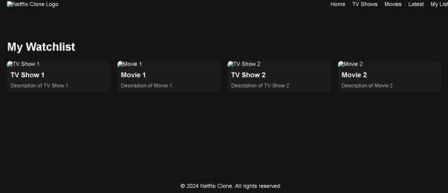

Tv shows page.html –

|  |
| --- |
| <!DOCTYPE html>  <html lang="en">  <head>  <meta charset="UTF-8">  <meta name="viewport" content="width=device-width, initial-scale=1.0">  <title>TV Shows - Netflix Clone</title>  <style> body { margin: 0; font-family: Arial, sans-serif; |

|  |
| --- |
| background-color: #141414; color: #fff;  }  header { display: flex; justify-content: space-between; align-items: center; padding: 10px 20px; background-color: #141414; position: fixed; width: 100%; top: 0; z-index: 1000;  }    .logo img { width: 100px;  }  nav ul { list-style: none; display: flex; margin: 0; padding: 0;  }  nav ul li { margin-right: 20px;  }  nav ul li a {  text-decoration: none; color: #fff;  }    .container { margin-top: 80px; padding: 20px;  }    .content { display: flex; flex-wrap: wrap; gap: 20px; justify-content: center;  } |

|  |
| --- |
| .card { flex: 1 1 calc(25% - 20px); box-sizing: border-box; background-color: #1c1c1c; border-radius: 10px; overflow: hidden;  }    .card img { width: 100%; display: block;  }    .card h3 { margin: 10px; font-size: 1.2em;  }    .card p { margin: 0 10px 10px; font-size: 0.9em; color: #aaa;  }  footer { text-align: center; padding: 20px; background-color: #141414; position: fixed; width: 100%; bottom: 0;  }  </style>  </head>  <body>  <header>  <div class="logo">  <img src="logo.png" alt="Netflix Clone Logo">  </div>  <nav>  <ul>  <li><a href="index.php">Home</a></li>  <li><a href="tv_shows.php">TV Shows</a></li>  <li><a href="movies.php">Movies</a></li>  <li><a href="latest.php">Latest</a></li>  <li><a href="my_list.php">My List</a></li>  </ul>  </nav> |

</header>

<div class="container">

<h1>TV Shows</h1>

<div class="content">

<!-- Example TV show cards -->

<div class="card">

<img src="tv_show1.jpg" alt="TV Show 1">

<h3>TV Show 1</h3>

<p>Description of TV Show 1</p>

</div>

<div class="card">

<img src="tv_show2.jpg" alt="TV Show 2">

<h3>TV Show 2</h3>

<p>Description of TV Show 2</p>

</div>

<div class="card">

<img src="tv_show3.jpg" alt="TV Show 3">

<h3>TV Show 3</h3>

<p>Description of TV Show 3</p>

</div>

<div class="card">

<img src="tv_show4.jpg" alt="TV Show 4">

<h3>TV Show 4</h3>

<p>Description of TV Show 4</p>

</div>

<!-- Add more TV show cards as needed -->

</div>

</div>

<footer>

<p>&copy; 2024 Netflix Clone. All rights reserved.</p>

</footer>

</body>

</html>

**8. Result**

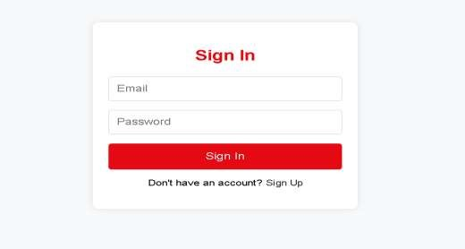

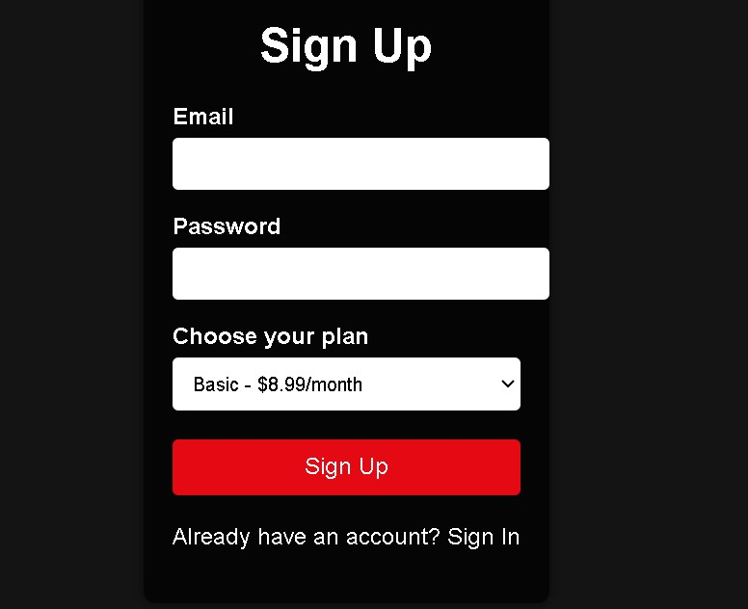

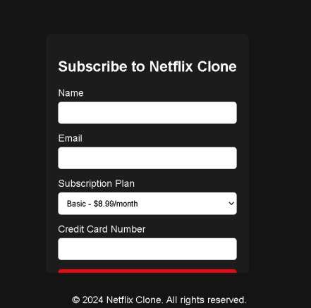

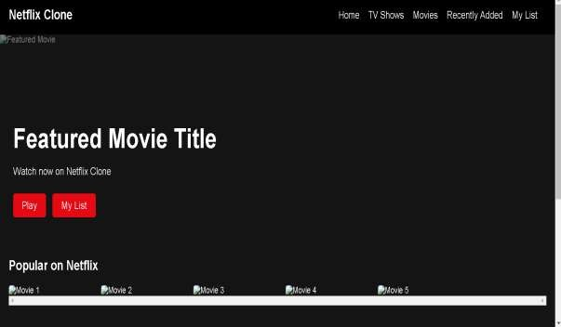

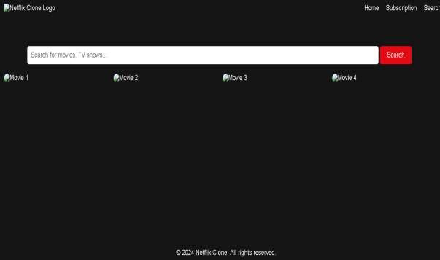

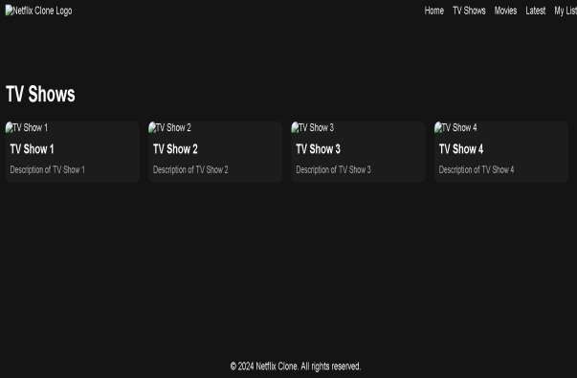

**9.CONCLUSION**

The Netflix clone project is a comprehensive endeavour aimed at replicating the core functionalities and user experience of the popular streaming service, Netflix. Through meticulous design and development, the project successfully achieves a high-quality web application that mirrors the aesthetic appeal and intuitive usability of Netflix.Implement personalized recommendations based on a user’s viewing history. Machine learning algorithms can analyze user preferences and suggest relevant content. Notify users about new releases, personalized recommendations, or special events. Push notifications keep users engaged and informed. Allow users to share their favorite shows on social media or create watch parties with friends. Social integration can enhance the user experience.

**REFERENCES**

1. [MDN Web Docs](https://developer.mozilla.org/)
2. [W3Schools 3](https://www.w3schools.com/). [Bootstrap](https://getbootstrap.com/)
3. [CSS Tricks](https://css-tricks.com/)
4. [Shopify](https://www.shopify.com/)
5. *GeeksforGeeks*